**Client-Side App Rubric** <https://github.com/denisecase/pbl-lifeline-links>

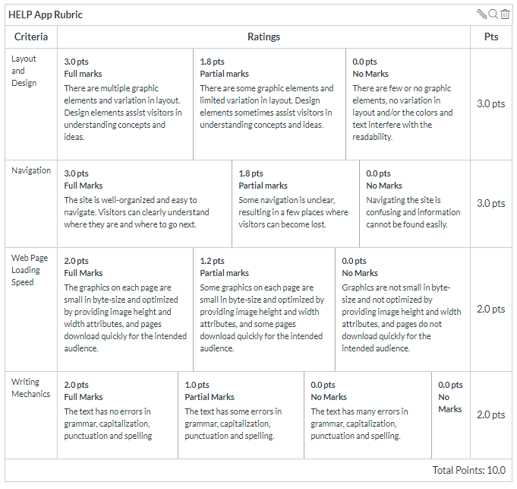

**Team reviewed: section 4 group 5**

**Link to the web site:** <https://chetankudaravalli16.github.io/Help-app-05/>

**Layout and Design**

Score: 1.8 Partial marks

Comments: Potentially this website is for the older audience, it would be benifical to increase font size for nav bar on the side. When screen gets smaller the home page portion is left aligned while every other page is centered.

**Navigation**

Score: 3.0

Comments:

**Loading Speed:**

Score: 2.0

Comments: Only thing that takes a few extra seconds is nav bar picture

**Writing Mechanics:**

Score: 2.0

Comments:

**General remarks:  
  
looks good**

**Review performed by: Group 6**

**Date and time performed: 12:40 12/5/19**